**Dr. AMBEDKAR INSTITUTE OF TECHNOLOGY**

**(An Autonomous Institute, Affiliated to Visvesvaraya Technological University, Belagavi, Accredited by NAAC, with ‘A+’ Grade)**

**Near Jnana Bharathi Campus, Bengaluru – 560056**



**DEPARTMENT OF COMPUTER SCIENCE AND ENGINEERING**

**SEMESTER-V**

**Submitted by:**

**MALAGOWDA SOMALING PATIL**

**1DA23CS100**

**Faculty Incharge:**

**Dr. Praveena M V**

**Dept. of CSE**

**Handling HTTP Requests and Responses**

**ColorGet.html**

**<html>**

**<body>**

**<center>**

**<h1>Servlet Prog 1</h1>**

**<h3>MALAGOWDA SOMALING PATIL</h3>**

**<h4>USN : 1DA23CS100</h4>**

**<form action="ColorGetServlet1">**

**<b>Color:</b>**

**<select name="color">**

**<option>Red</option>**

**<option>Green</option>**

**<option>Blue</option>**

**</select>**

**<br><br>**

**<input type="submit" value="Submit">**

**</form>**

**</center>**

**</body>**

**</html>**

**ColorGetServlet.java**

***//Name: MALAGOWDA SOMALING PATIL***

***//USN: 1DA23CS100***

**import java.io.*\**;**

**import javax.servlet.*\**;**

**import javax.servlet.http.*\**;**

**public class ColorGetServlet1 extends HttpServlet {**

**public void doGet(HttpServletRequest request, HttpServletResponse response)**

**throws ServletException, IOException {**

**String color = request.getParameter("color");**

**response.setContentType("text/html");**

**PrintWriter out = response.getWriter();**

**out.println("<b>The selected color is: " + color + "</b>");**

**out.close();**

**}**

**}**

**OUTPUT:**

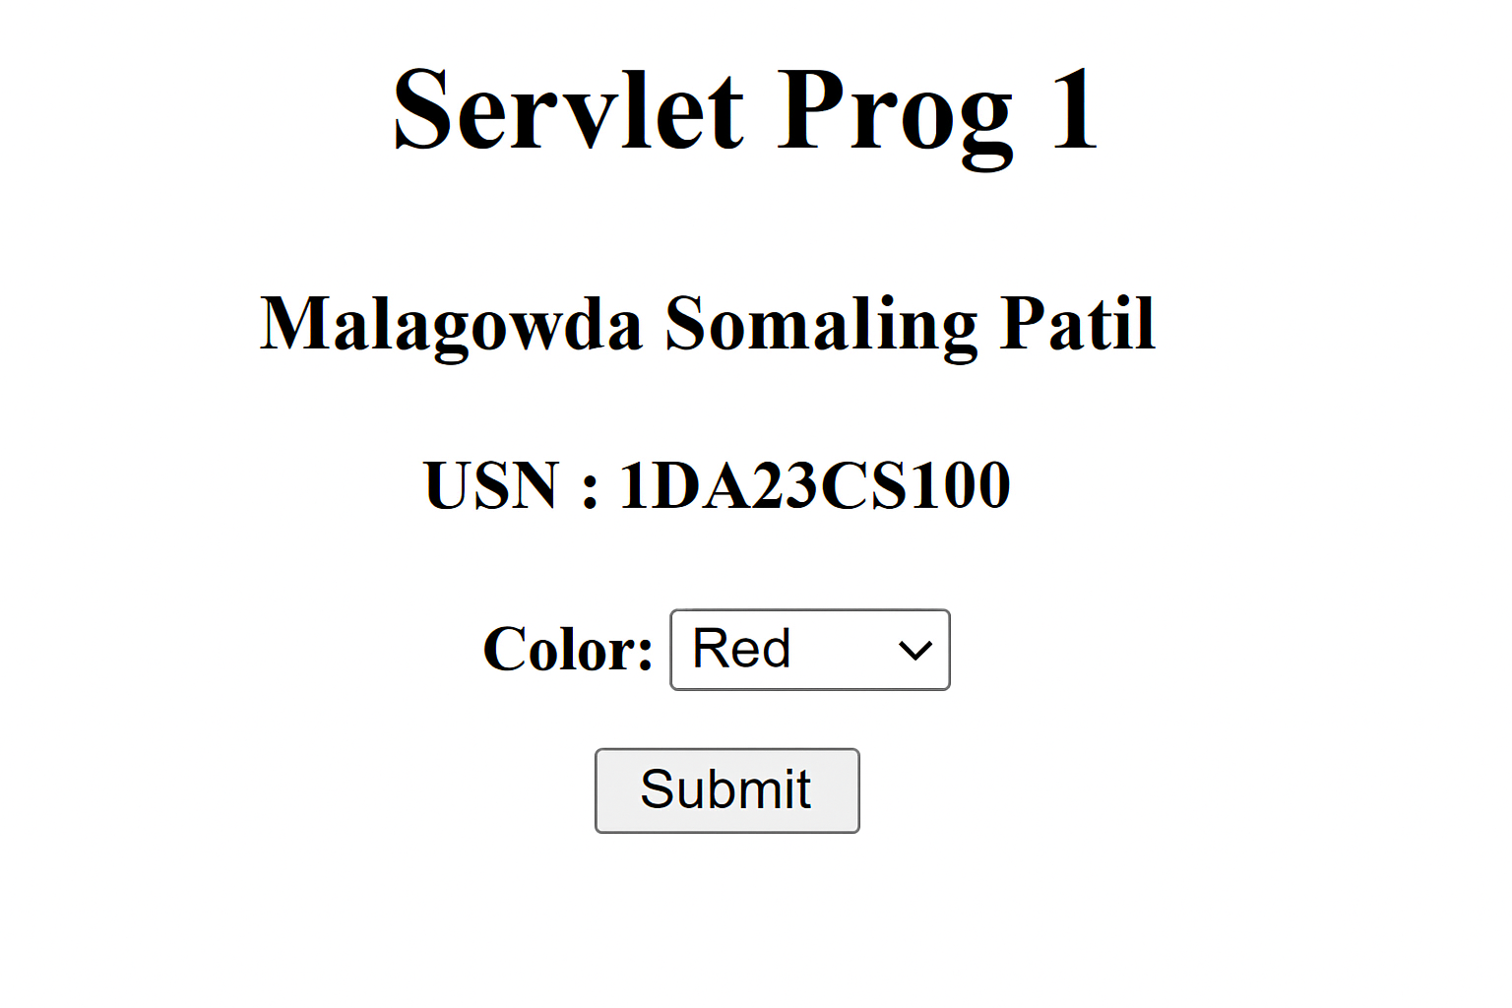

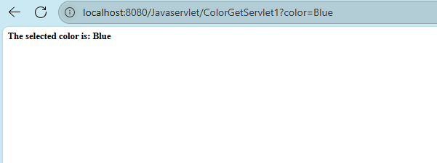

**ColorPost.html**

**<html>**

**<body>**

**<center>**

**<h1>Servlet Prog 2</h1>**

**<h3>MALAGOWDA SOMALING PATIL</h3>**

**<h4>USN: 1DA23CS100</h4>**

**<form method="post" action="ColorPostServlet">**

**<b>Color:</b>**

**<select name="color">**

**<option>Red</option>**

**<option>Green</option>**

**<option>Blue</option>**

**</select><br><br>**

**<input type="submit" value="Submit">**

**</form>**

**</center>**

**</body>**

**</html>**

**ColorPostServlet.java**

***//Name: MALAGOWDA SOMALING PATIL***

***//USN: 1DA23CS100***

**import java.io.*\**;**

**import javax.servlet.*\**;**

**import javax.servlet.http.*\**;**

**public class ColorPostServlet extends HttpServlet {**

**public void doPost(HttpServletRequest req, HttpServletResponse res)**

**throws ServletException, IOException {**

**String color = req.getParameter("color");**

**res.setContentType("text/html");**

**PrintWriter out = res.getWriter();**

**out.println("<b>The selected color is: " + color + "</b>");**

**out.close();**

**}**

**}**

**OUTPUT:**



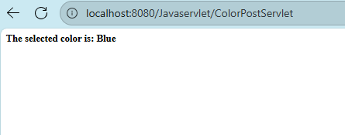

**Cookies in Servlet**

**AddCookie.html**

**<html>**

**<body>**

**<center>**

**<h1>Servlet Prog 2</h1>**

**<h3>Name: MALAGOWDA SOMALING PATIL</h3>**

**<h4>USN: 1DA23CS100</h4>**

**<form method="post" action="AddCookieServlet">**

**<b>Enter a value for MyCookie:</b>**

**<input type="text" name="data" size="25">**

**<input type="submit" value="Submit">**

**</form>**

**</center>**

**</body>**

**</html>**

**AddCookieServlet.java**

***//Name: MALAGOWDA SOMALING PATIL***

***//USN: 1DA23CS100***

**import java.io.*\**;**

**import javax.servlet.*\**;**

**import javax.servlet.http.*\**;**

**public class AddCookieServlet extends HttpServlet {**

**public void doPost(HttpServletRequest req, HttpServletResponse res)**

**throws ServletException, IOException {**

**String data = req.getParameter("data");**

**Cookie cookie = new Cookie("MyCookie", data);**

**res.addCookie(cookie);**

**res.setContentType("text/html");**

**PrintWriter out = res.getWriter();**

**out.println("<b>MyCookie has been set to: " + data + "</b>");**

**out.close();**

**}**

**}**

**GetCookiesServlet.java**

***//Name: MALAGOWDA SOMALING PATIL***

***//USN: 1DA23CS100***

**import java.io.*\**;**

**import javax.servlet.*\**;**

**import javax.servlet.http.*\**;**

**public class GetCookiesServlet extends HttpServlet {**

**public void doGet(HttpServletRequest req, HttpServletResponse res)**

**throws ServletException, IOException {**

**Cookie[] cookies = req.getCookies();**

**res.setContentType("text/html");**

**PrintWriter out = res.getWriter();**

**out.println("<b>");**

**if (cookies != null)**

**for (Cookie c : cookies)**

**out.println("name=" + c.getName() + "; value=" + c.getValue() + "<br>");**

**else**

**out.println("No cookies found");**

**out.close();**

**}**

**}**

**OUTPUT:**

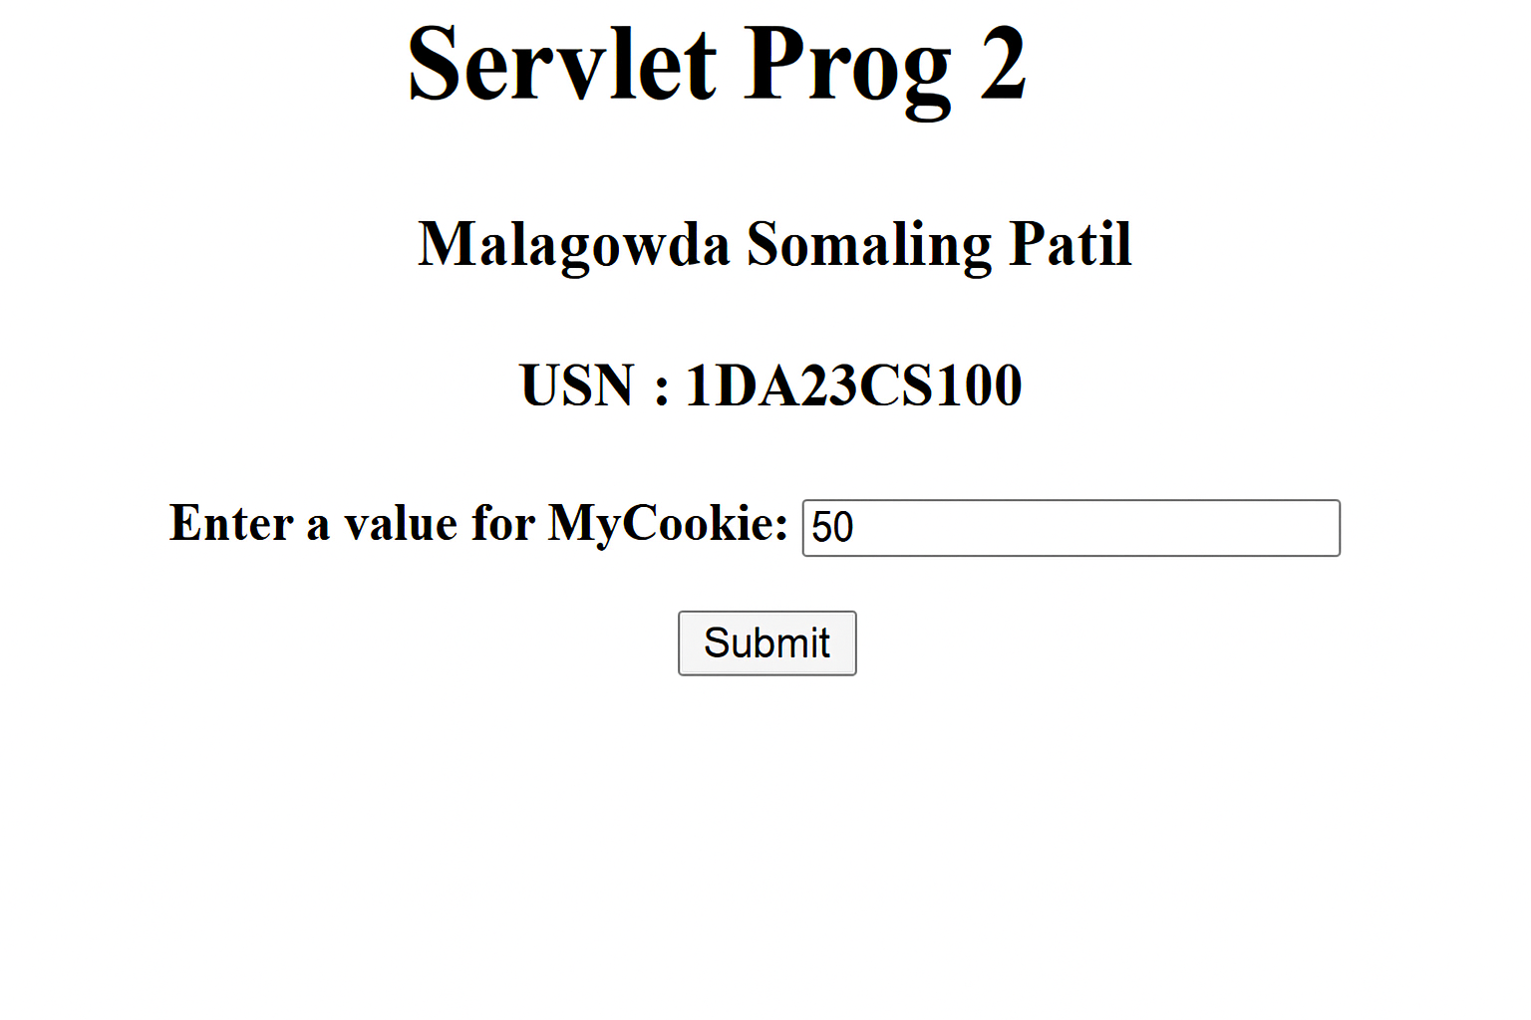

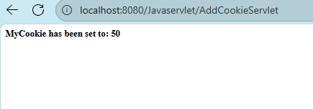

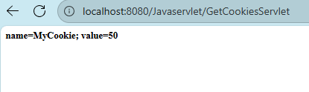

**Session Tracking:**

***//Name: MALAGOWDA SOMALING PATIL***

***//USN: 1DA23CS100***

**import java.io.*\**;**

**import java.util.*\**;**

**import javax.servlet.*\**;**

**import javax.servlet.http.*\**;**

**public class DateServlet extends HttpServlet {**

**public void doGet(HttpServletRequest req, HttpServletResponse res)**

**throws ServletException, IOException {**

**HttpSession hs = req.getSession(true);**

**res.setContentType("text/html");**

**PrintWriter out = res.getWriter();**

**out.print("<b>");**

**Date date = (Date) hs.getAttribute("date");**

**if (date != null) out.print("Last access: " + date + "<br>");**

**date = new Date();**

**hs.setAttribute("date", date);**

**out.println("Current date: " + date);**

**}**

**}**

**OUTPUT:**

**First access**

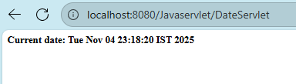

**Second access**

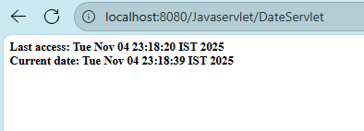

**JSP - Java Servlet Pages**

**Welcome program**

**<html>**

**<body>**

**<% out.print("Name : MALAGOWDA SOMALING PATIL "); %>**

**<% out.print("USN : 1DA23CS100"); %>**

**<% out.print("Welcome to JSP"); %>**

**</body>**

**</html>**

**OUTPUT:**

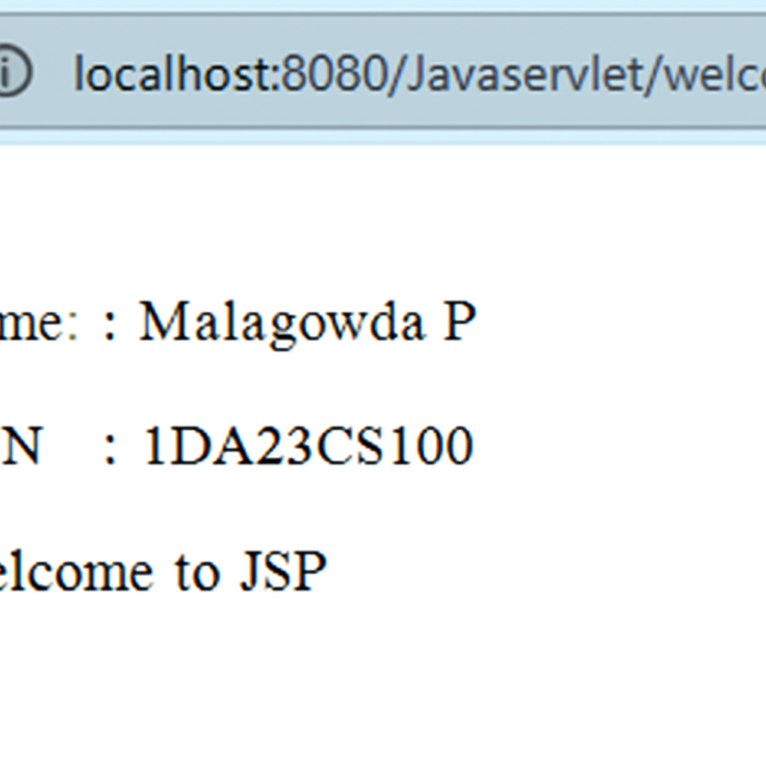

**Display Username:**

**<form action="welcome.jsp">**

**<input type="text" name="uname">**

**<input type="submit" value="Go">**

**</form>**

**<html><body>**

**<%**

**String name = request.getParameter("uname");**

**out.print("Welcome " + name);**

**%>**

**</body></html>**

**OUTPUT:**

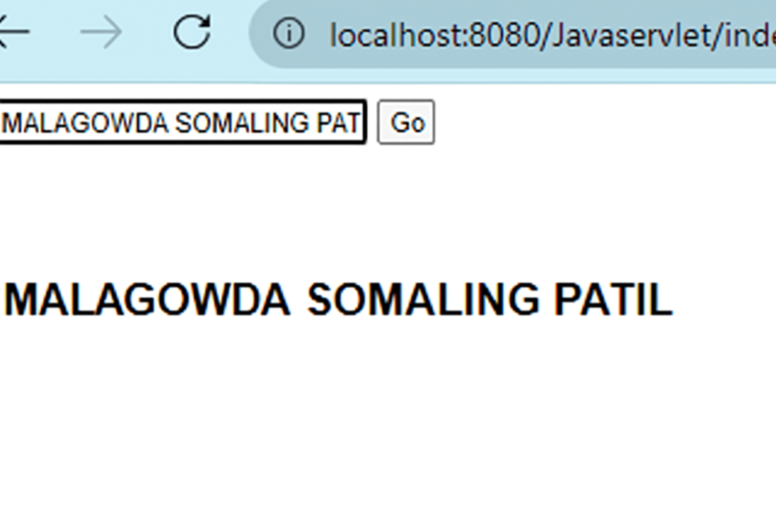

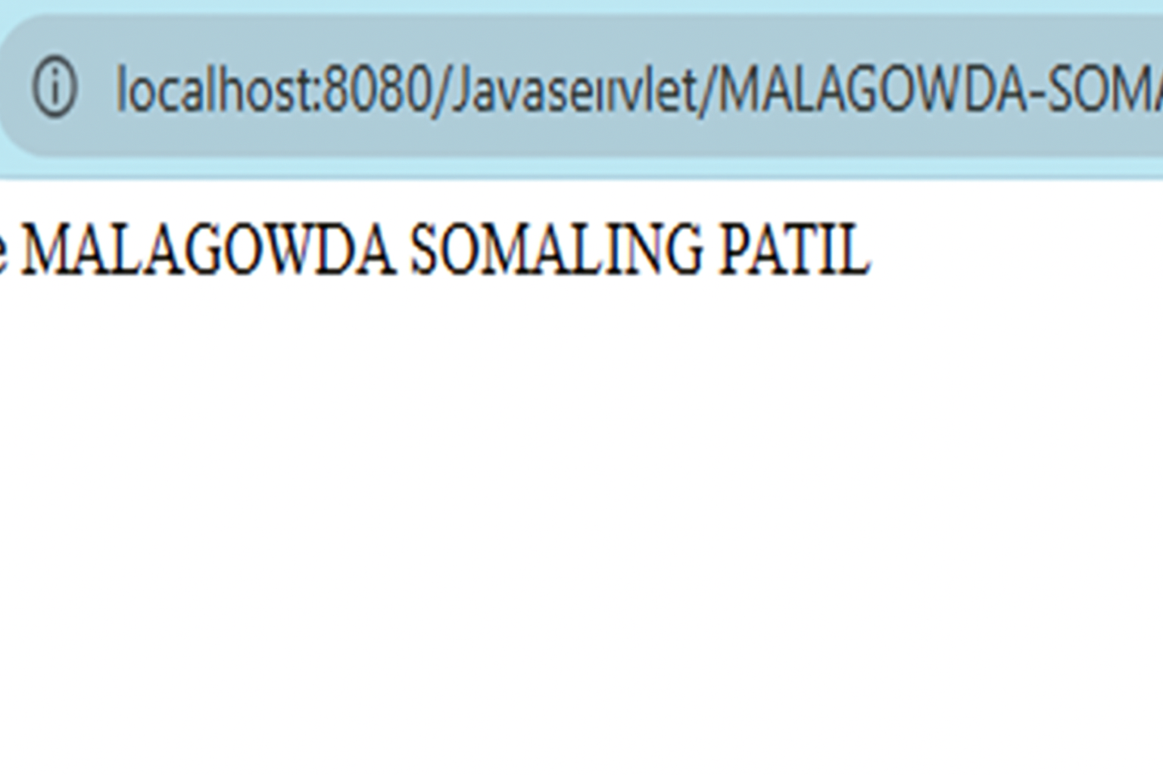

**Expression Tag:**

**<html><body>**

**Current Time: <%= java.util.Calendar.getInstance().getTime() %>**

**</body></html>**

**OUTPUT:**

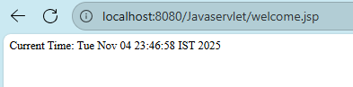

**Declaration Tag**

**<html><body>**

**<%! int cube(int n){ return n*n*n; } %>**

**<%= "Cube of 3 is: " + cube(3) %>**

**</body></html>**

**OUTPUT:**

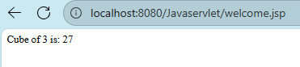

**SWINGS:**

***//Name: MALAGOWDA SOMALING PATIL***

***//USN: 1DA23CS100***

**import javax.swing.*\**;**

**class swindemo {**

**swindemo() {**

**JFrame jfrm = new JFrame("A Simple Swing Application");**

**jfrm.setSize(275, 100);**

**jfrm.setDefaultCloseOperation(JFrame.EXIT_ON_CLOSE);**

**JLabel jlab = new JLabel("MALAGOWDA SOMALING PATIL");**

**jfrm.add(jlab);**

**jfrm.setVisible(true);**

**}**

**public static void main(String args[]) {**

**SwingUtilities.invokeLater(new Runnable() {**

**public void run() {**

**new SwingDemo();**

**}**

**});**

**}**

**}**

**OUTPUT:**

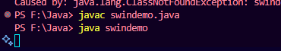

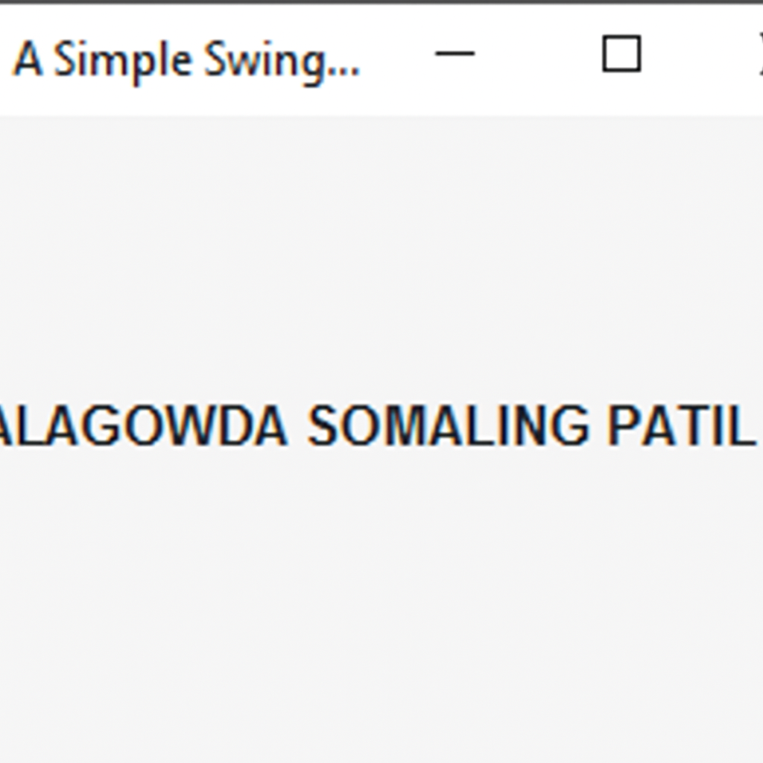

**Event Handling in Swing:**

***//Name: MALAGOWDA SOMALING PATIL***

***//USN: 1DA23CS100***

**import java.awt.*\**;**

**import java.awt.event.*\**;**

**import javax.swing.*\**;**

**class EventDemo {**

**JLabel jlab;**

**EventDemo() {**

**JFrame jfrm = new JFrame("An Event Example");**

**jfrm.setLayout(new FlowLayout());**

**jfrm.setSize(220, 90);**

**jfrm.setDefaultCloseOperation(JFrame.EXIT_ON_CLOSE);**

**JButton jbtnAlpha = new JButton("Alpha");**

**JButton jbtnBeta = new JButton("Beta");**

**jbtnAlpha.addActionListener(new ActionListener() {**

**public void actionPerformed(ActionEvent ae) {**

**jlab.setText("Alpha was pressed.");**

**}**

**});**

**jbtnBeta.addActionListener(new ActionListener() {**

**public void actionPerformed(ActionEvent ae) {**

**jlab.setText("Beta was pressed.");**

**}**

**});**

**jfrm.add(jbtnAlpha);**

**jfrm.add(jbtnBeta);**

**jlab = new JLabel("Press a button.");**

**jfrm.add(jlab);**

**jfrm.setVisible(true);**

**}**

**public static void main(String args[]) {**

**SwingUtilities.invokeLater(new Runnable() {**

**public void run() {**

**new EventDemo();**

**}**

**});**

**}**

**}**

**OUTPUT:**



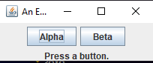

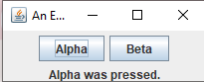

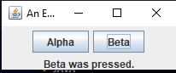

**Swing Applet Program:**

***//Name: MALAGOWDA SOMALING PATIL***

***//USN: 1DA23CS100***

**import javax.swing.*\**;**

**import java.awt.*\**;**

**import java.awt.event.*\**;**

**public class MySwingApp extends JFrame {**

**JButton jbtnAlpha;**

**JButton jbtnBeta;**

**JLabel jlab;**

**public MySwingApp() {**

**setLayout(new FlowLayout());**

**jbtnAlpha = new JButton("Alpha");**

**jbtnBeta = new JButton("Beta");**

**jbtnAlpha.addActionListener(new ActionListener() {**

**public void actionPerformed(ActionEvent le) {**

**jlab.setText("Alpha was pressed.");**

**}**

**});**

**jbtnBeta.addActionListener(new ActionListener() {**

**public void actionPerformed(ActionEvent le) {**

**jlab.setText("Beta was pressed.");**

**}**

**});**

**add(jbtnAlpha);**

**add(jbtnBeta);**

**jlab = new JLabel("Press a button.");**

**add(jlab);**

**setTitle("Swing App (Java 11 Version)");**

**setSize(300, 150);**

**setDefaultCloseOperation(JFrame.EXIT_ON_CLOSE);**

**setVisible(true);**

**}**

**public static void main(String[] args) {**

***// Run on the Event Dispatch Thread***

**SwingUtilities.invokeLater(new Runnable() {**

**public void run() {**

**new MySwingApp();**

**}**

**});**

**}**

**}**

**OUTPUT:**

